Topology 1:

How many rounds did it take for the network to converge?

* It took 2 rounds for the network to converge.

What is the ID of the last node to coverage in each network?

* The last node to converge is node 0.

How many DV messages were sent in total until each network converged?

* There were 8 total messages sent out until the network converged.

Topology 2:

How many rounds did it take for each network to converge?

* It took 4 rounds for the network to converge.

What is the ID of the last node to coverage in each network?

* The last node to converge is node 0.

How many DV messages were sent in total until each network converged?

* There were 20 total messages sent out until the network converged.

Topology 3:

How many rounds did it take for each network to converge?

* It took 5 rounds for the network to converge.

What is the ID of the last node to converge in each network?

* The last node to converge is node 0.

How many DV messages were sent in total until each network converged?

* There were 60 total messages sent out until the network converged.

Routing table for Topology 1:

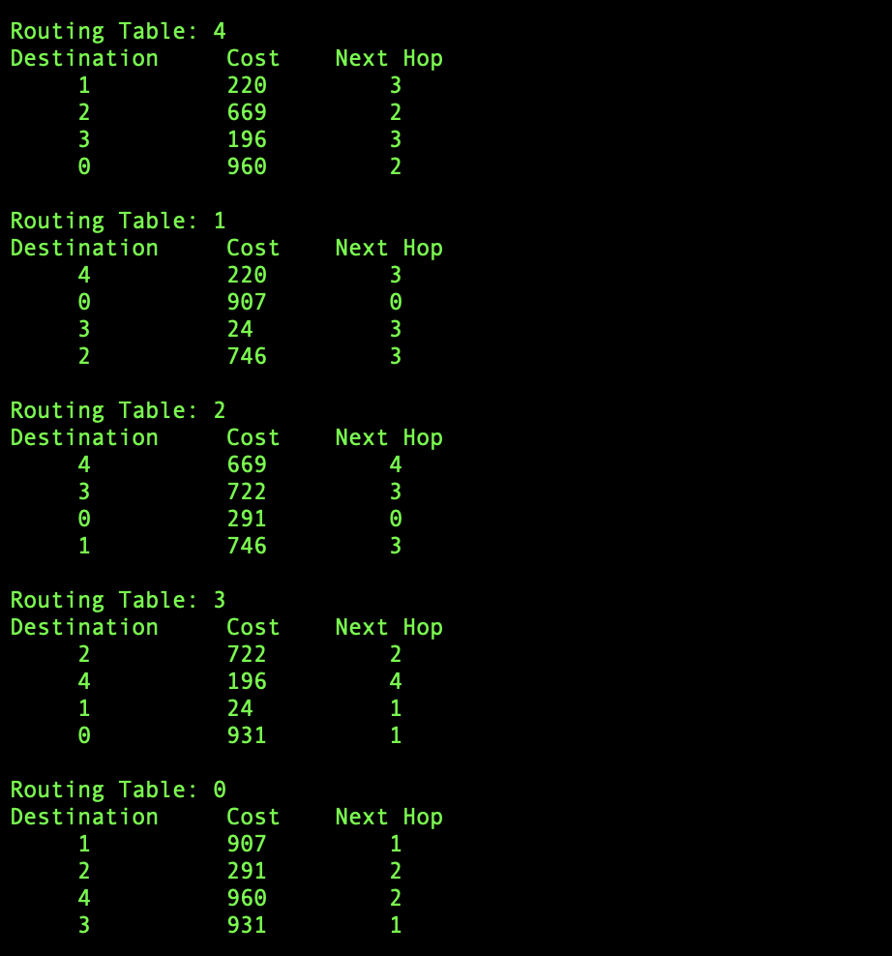

Routing table for Topology 2:

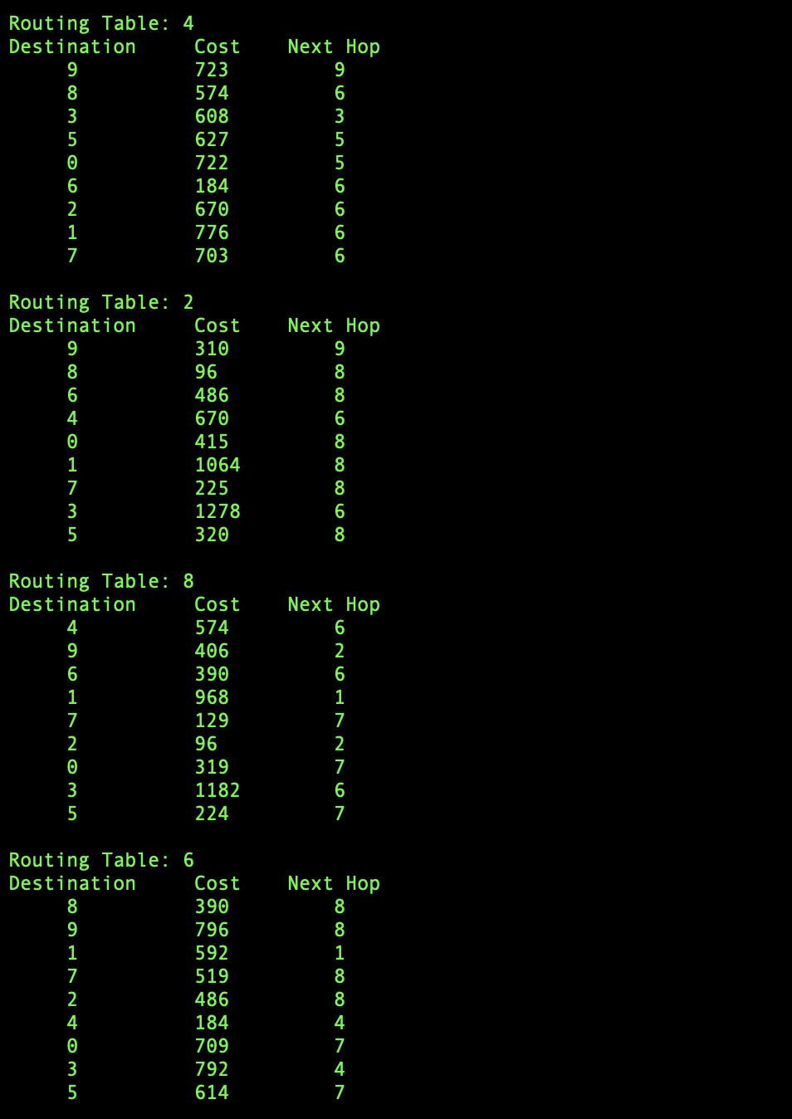

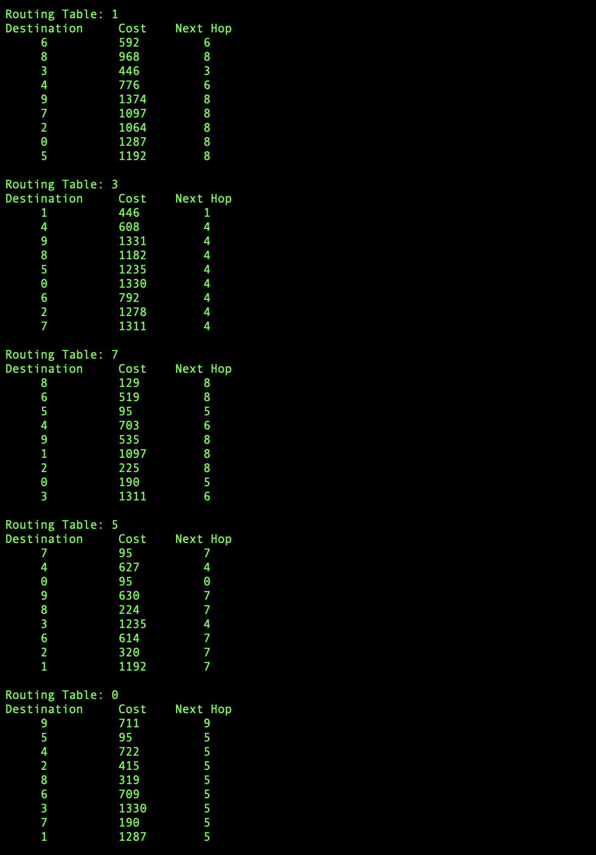

Routing Table for Topology 3:

